**Date:**  February 19th

**From:** Hakeem Buchanan (RIT Student)

**To:** Dr.Kaputa

**Subject: Lab 3**

# Introduction

The objective of Lab 3 was to build off of the vhdl in lab 2(the pwm) and add an axi module with vivado. The code would then be run through a Linux terminal. The values will be changed for the period and duty cycle through said terminal and adjusted to make a proper waveform

# Analysis

The Vivado project first uses the lab 2 code as a top file to create an overall general block diagram for the project. The inputs and outputs are then connected to a Zynq processor created. IP were created using the Lab 2 files in order to create a module using the same code. Ip was also created for the axi module which would connect to the linux terminal and drive the inputs for the code.

Afterwards a script was used to generate a file that could be read by the linux terminal to “flash” the board and drive the pins used to read the output.

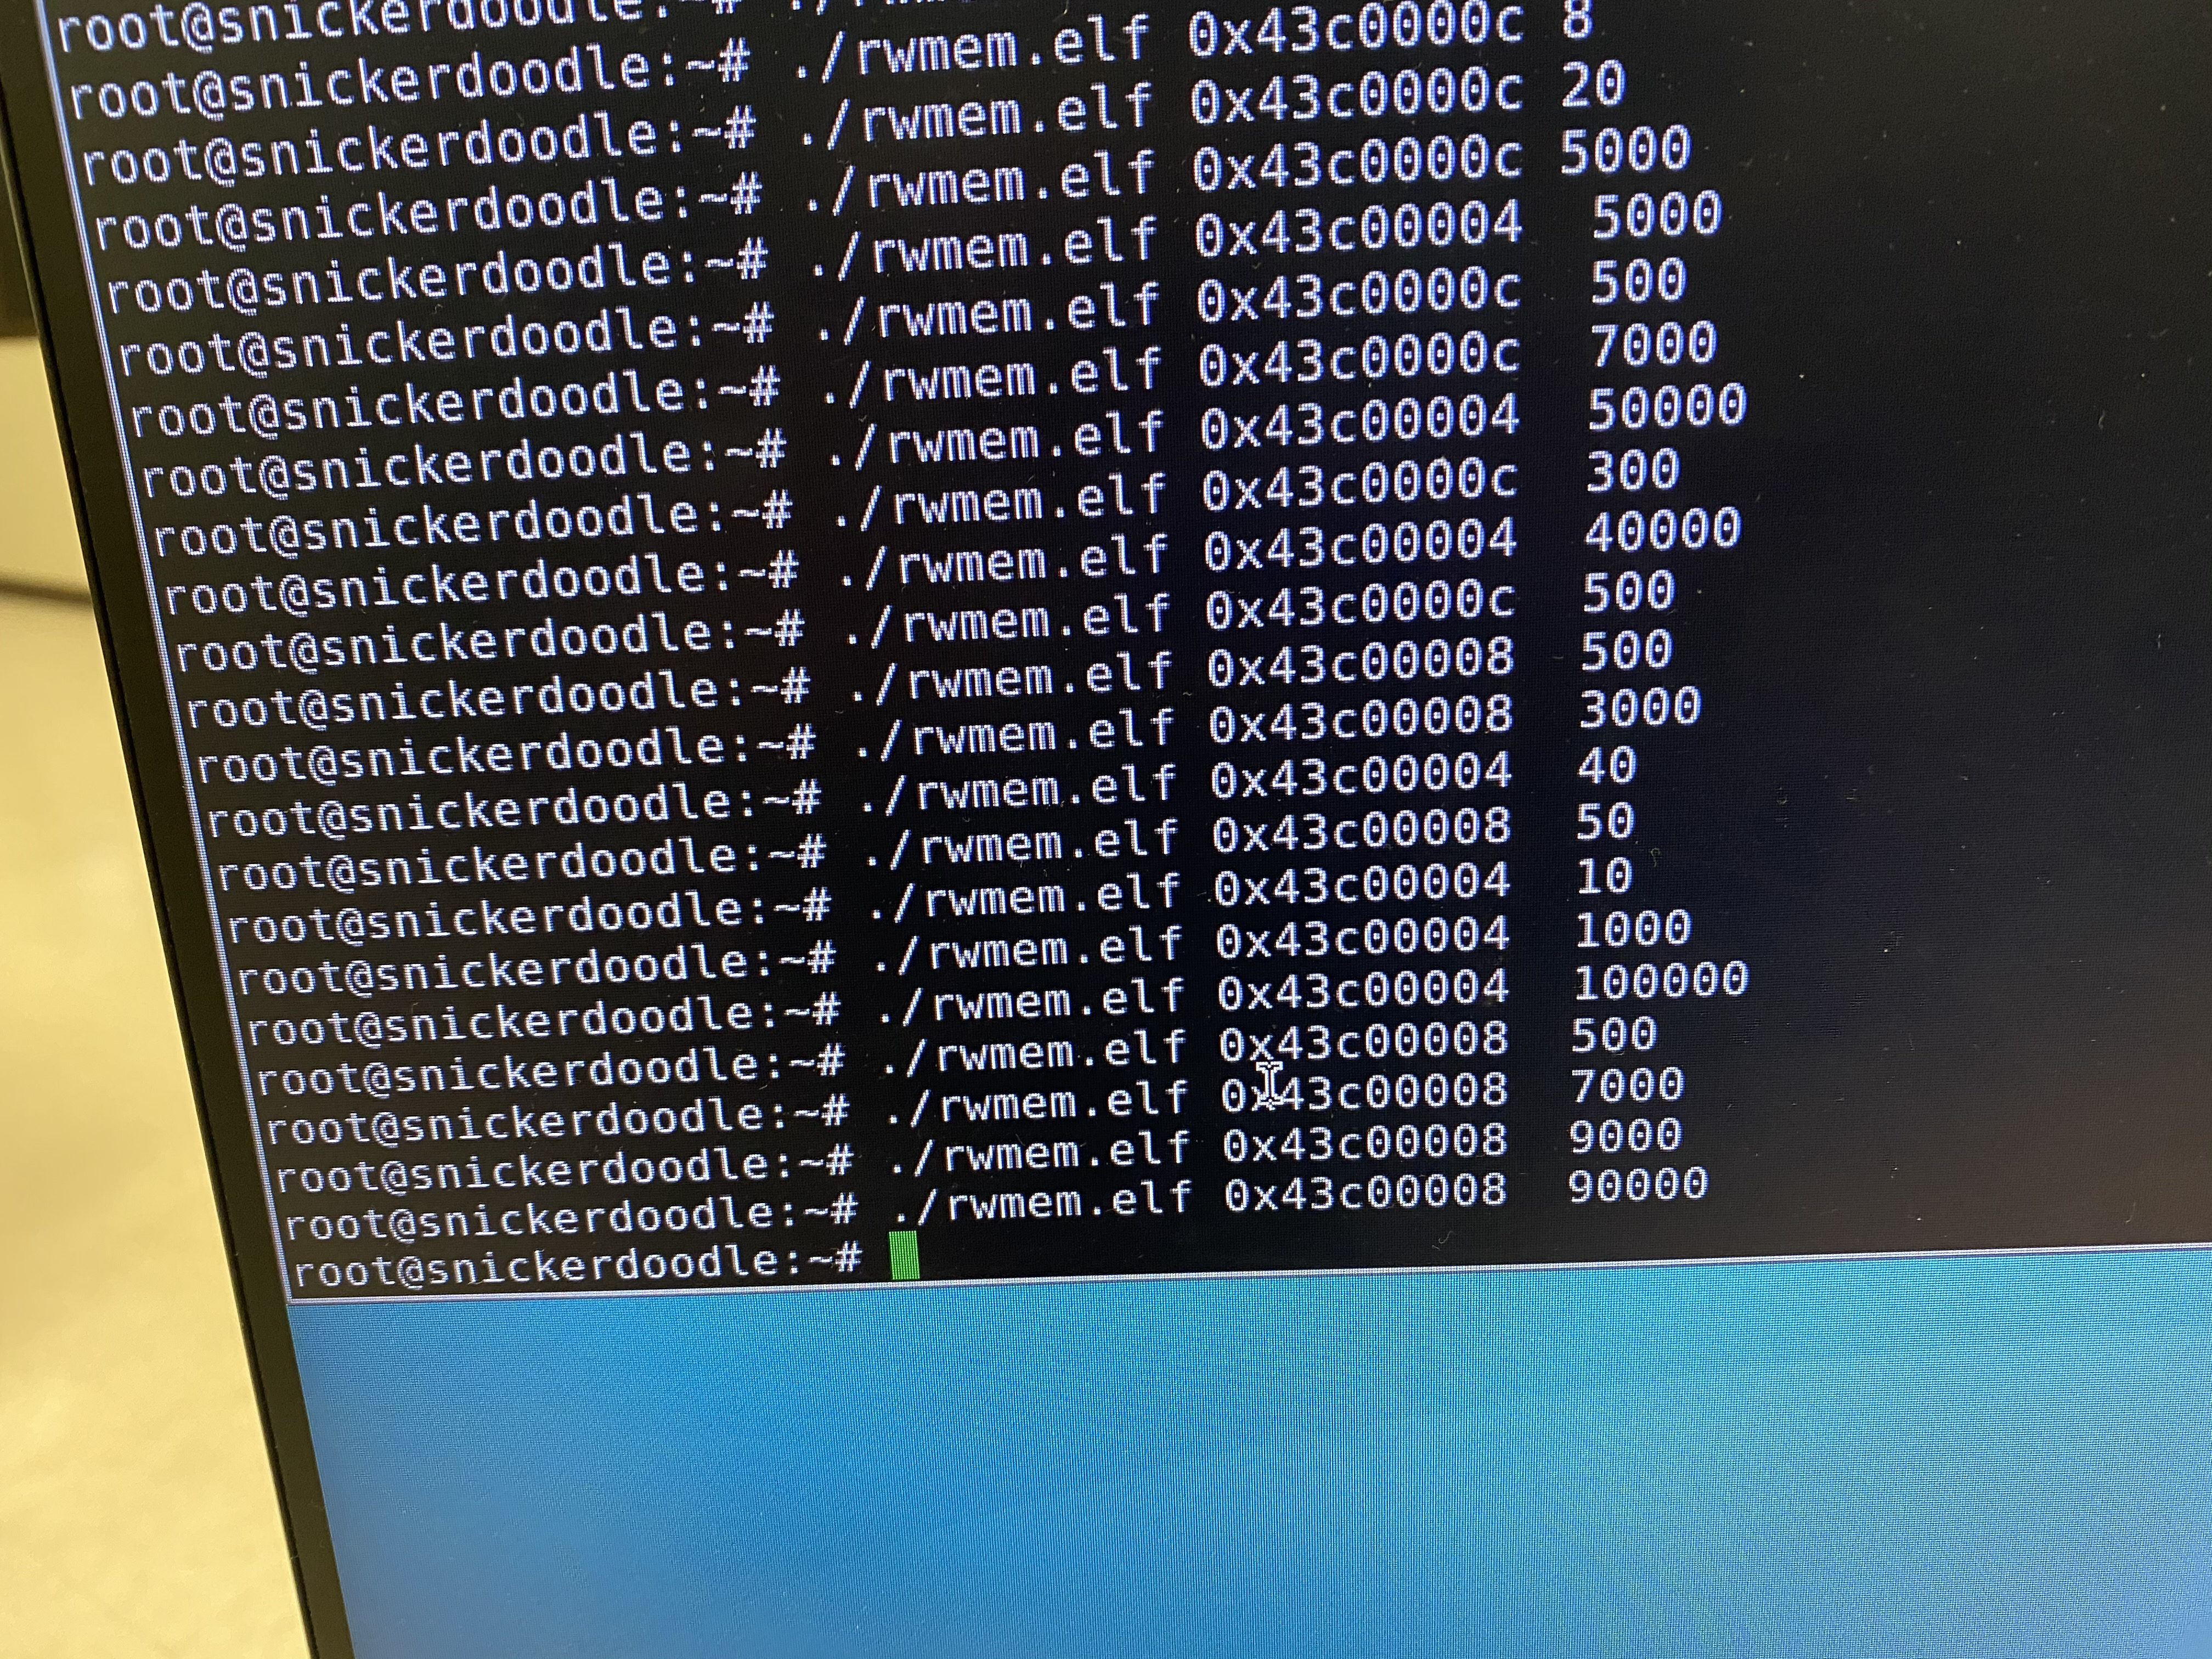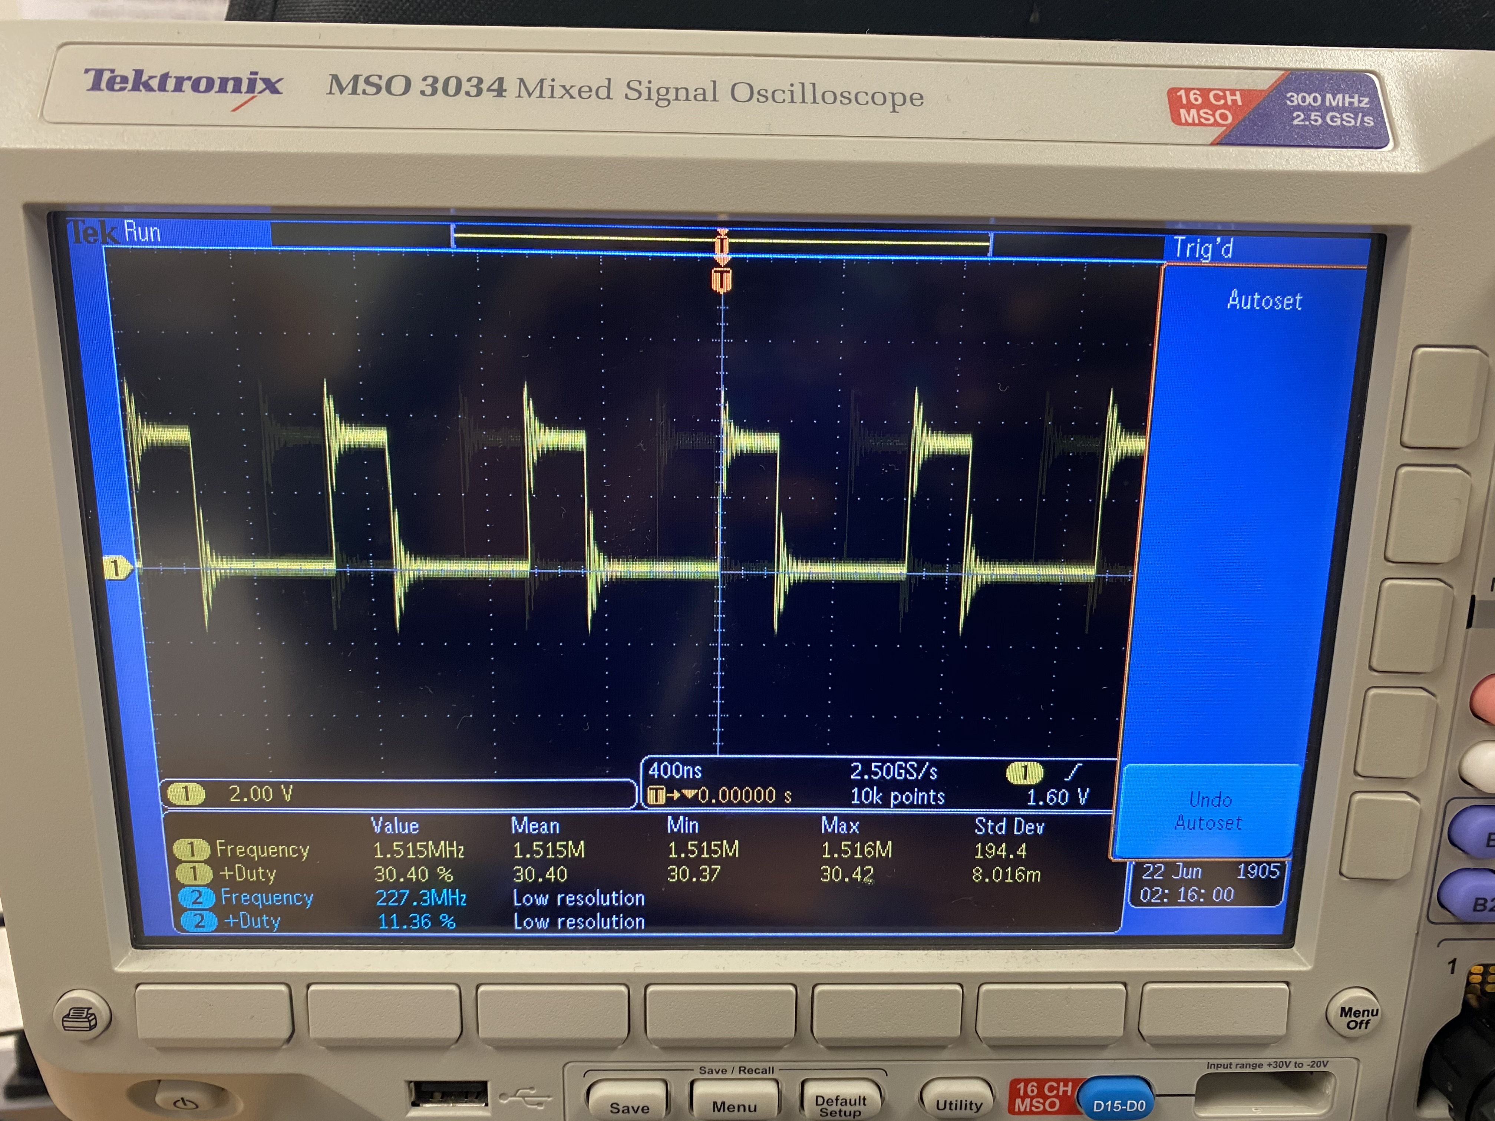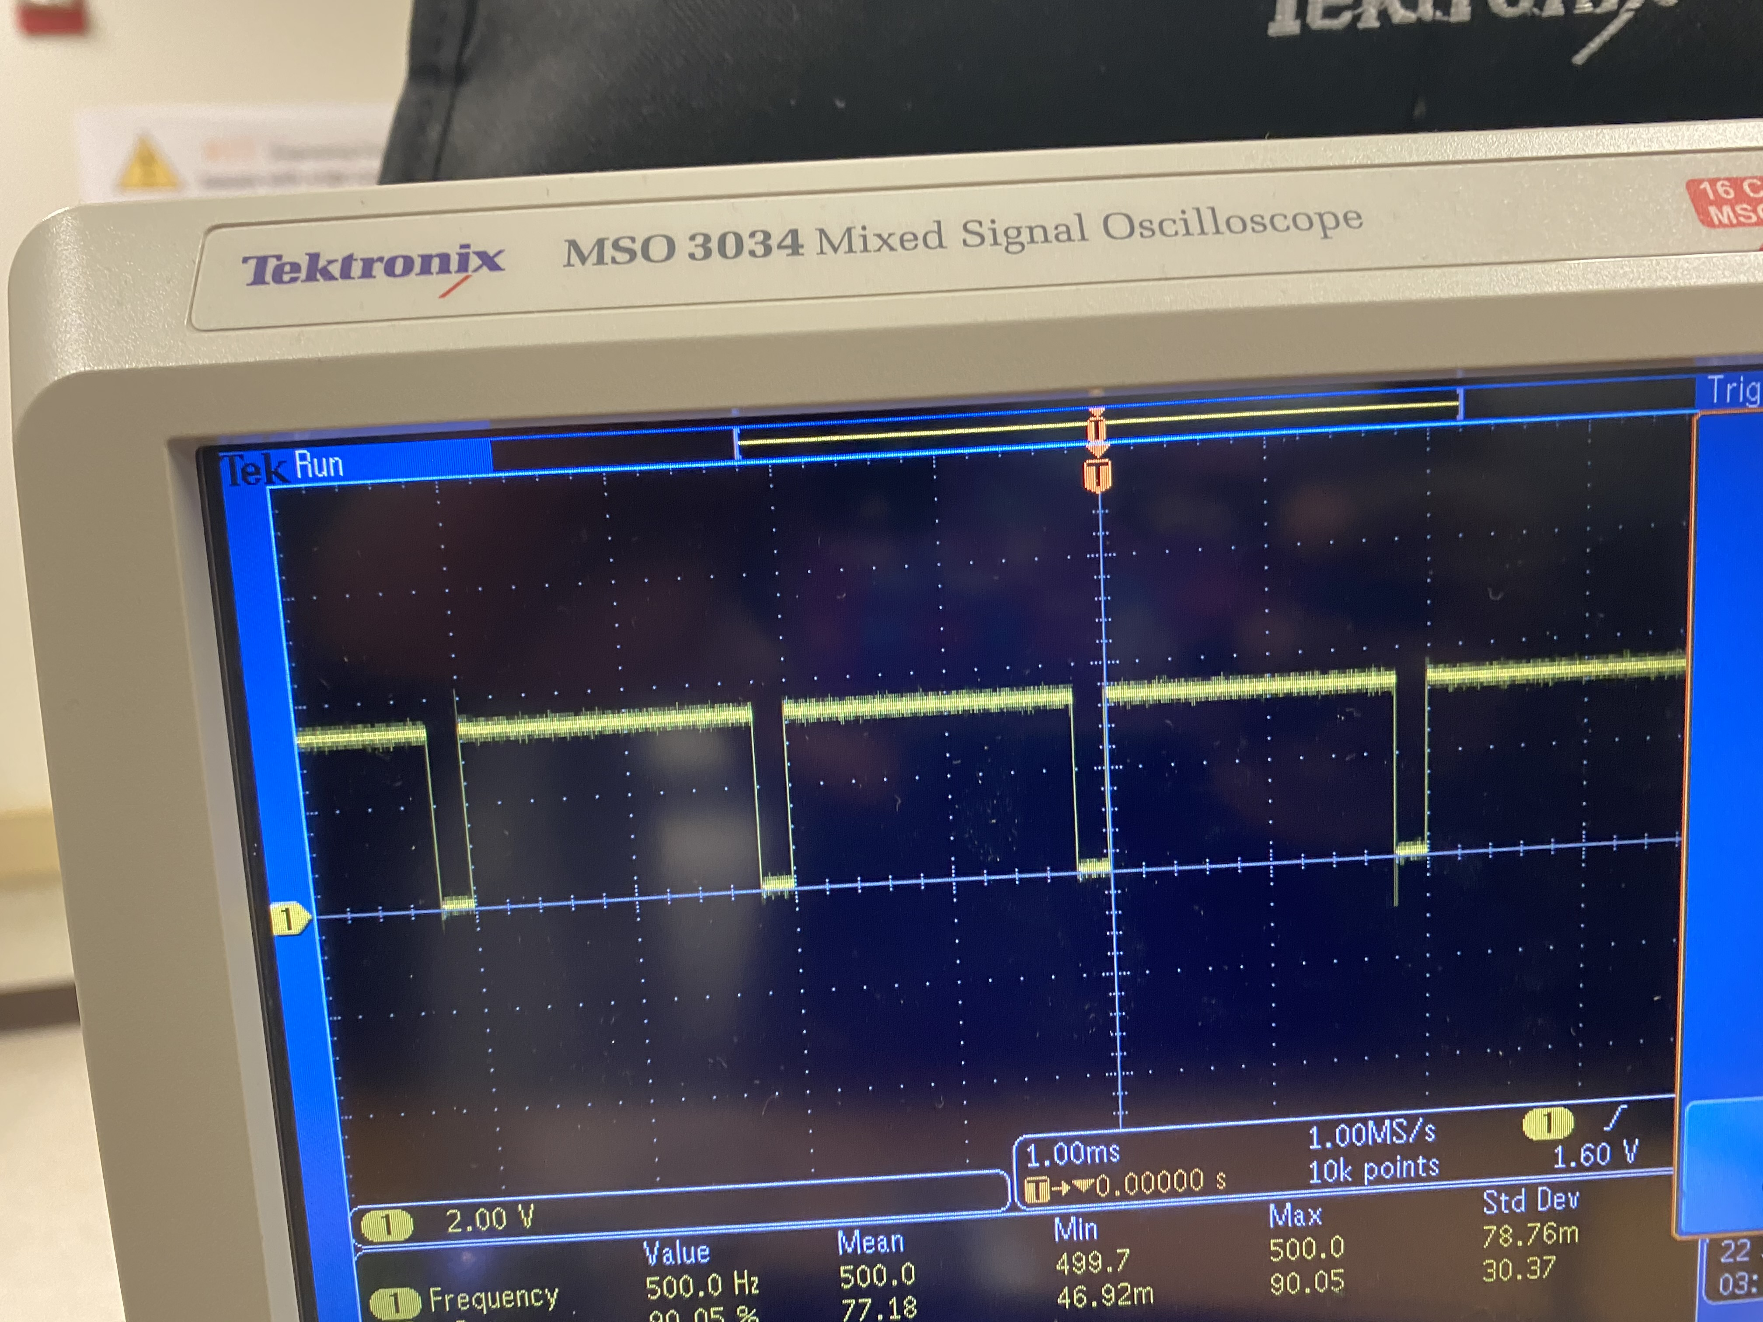

# Conclusion

* *Period and Duty Cycle changes well*
* *The Script can efficiently clean and run the code without issue.*
* *Some noise detected in the waveform.*